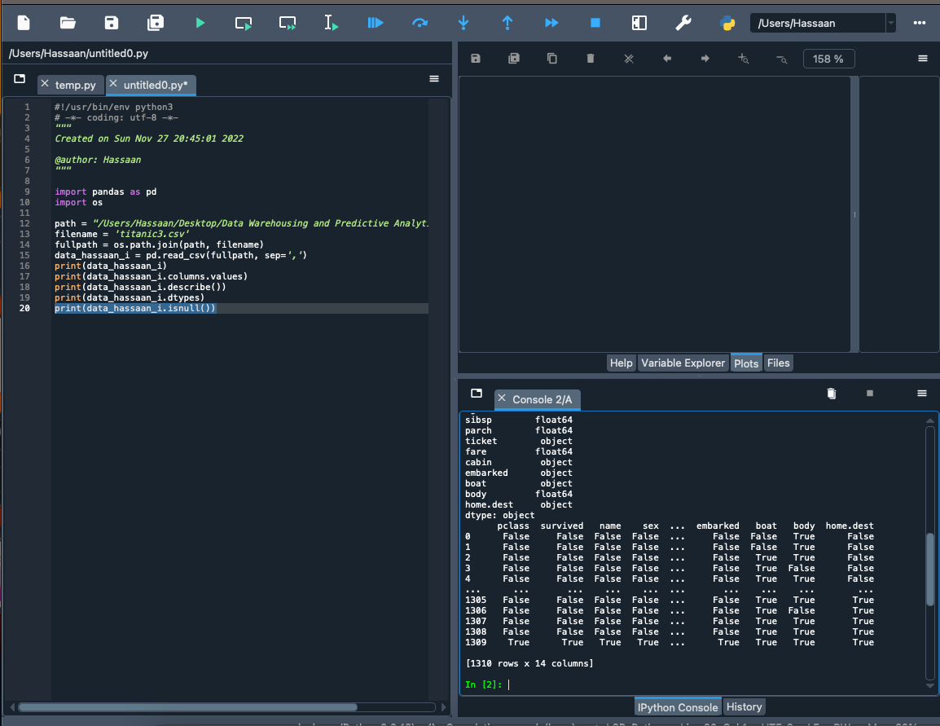

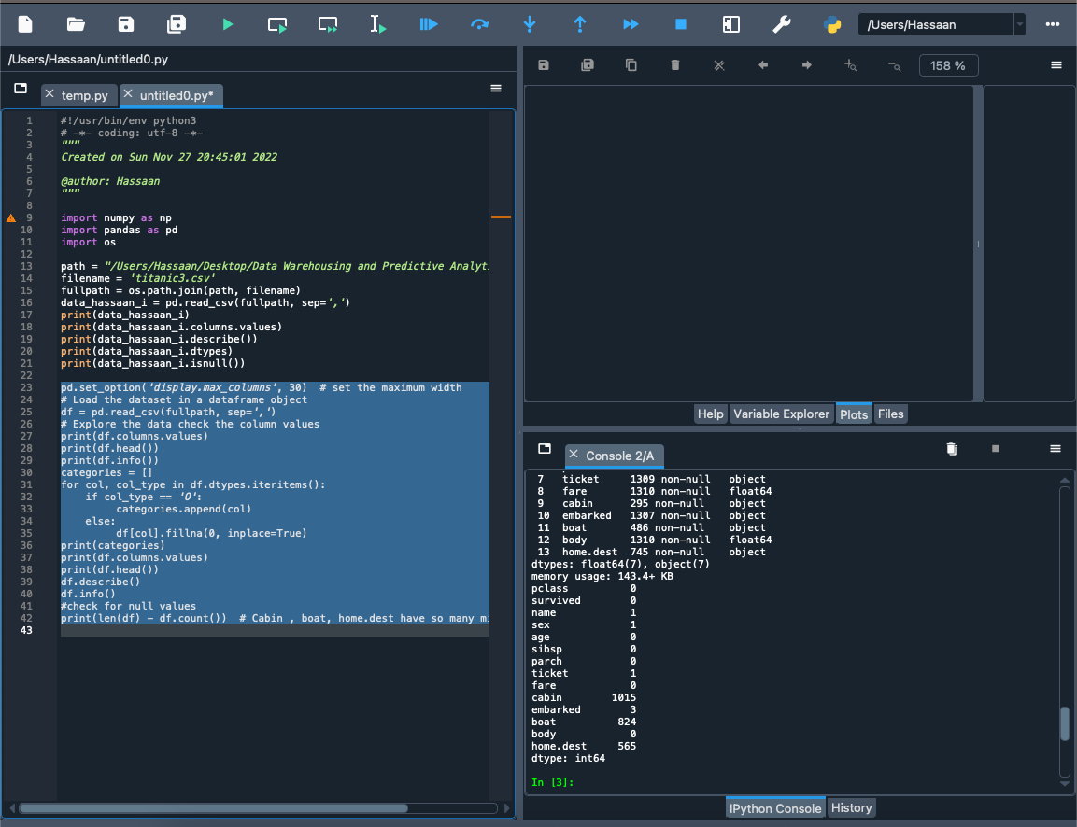

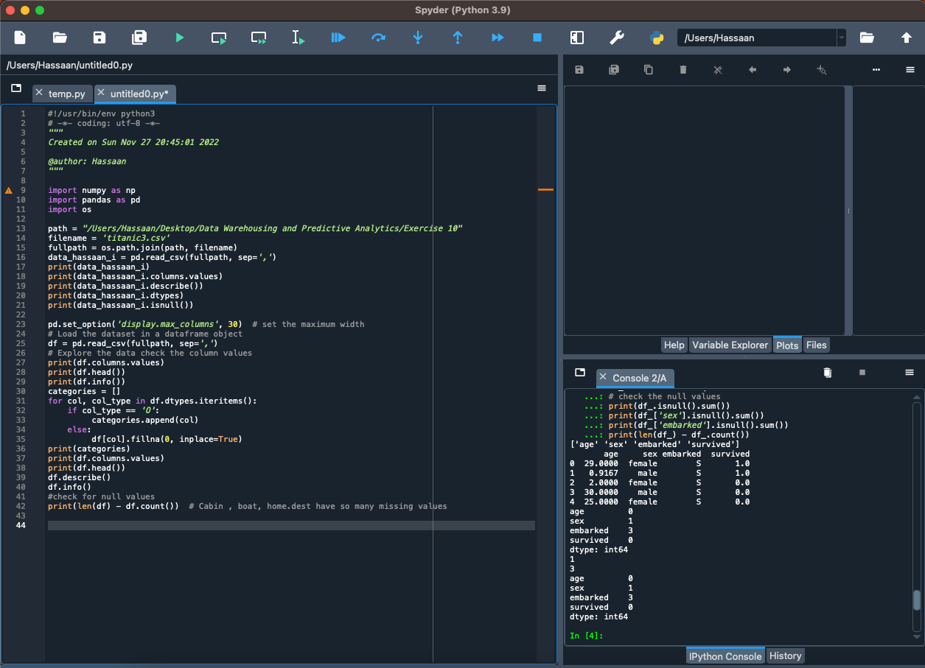

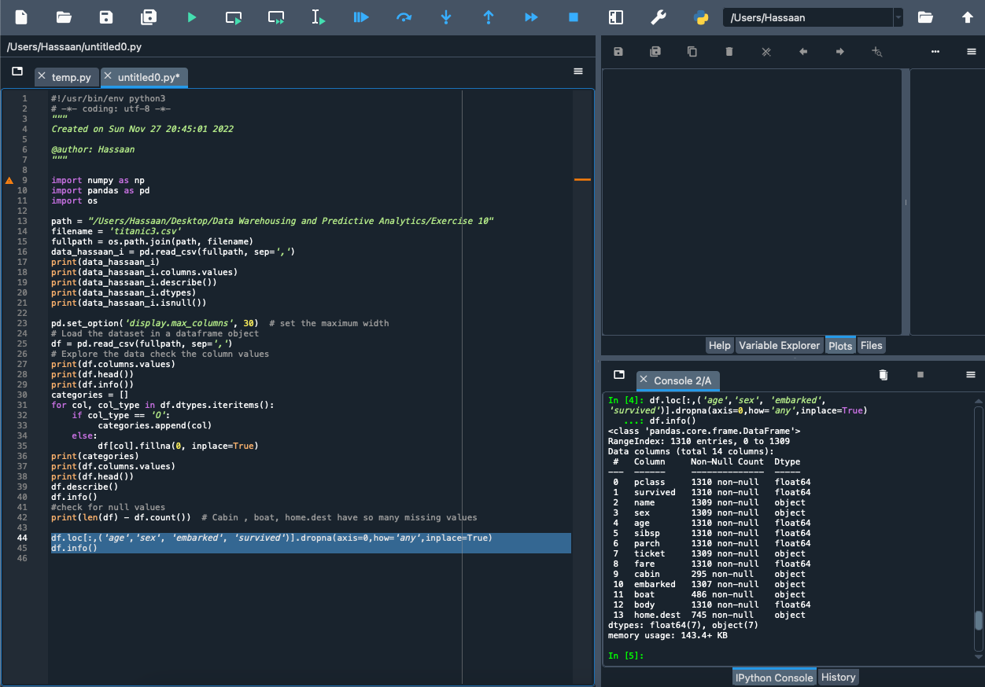

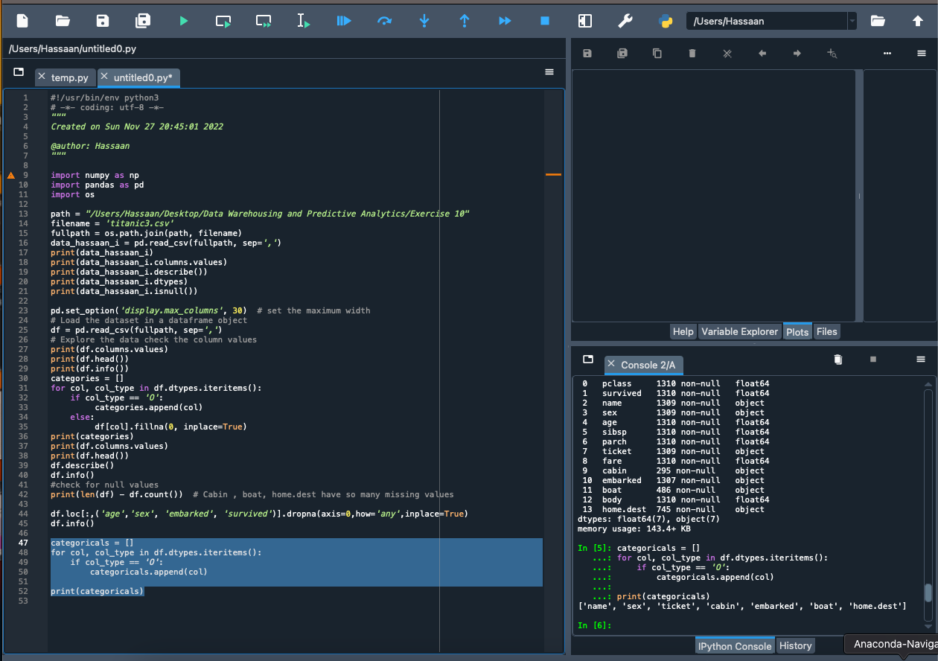

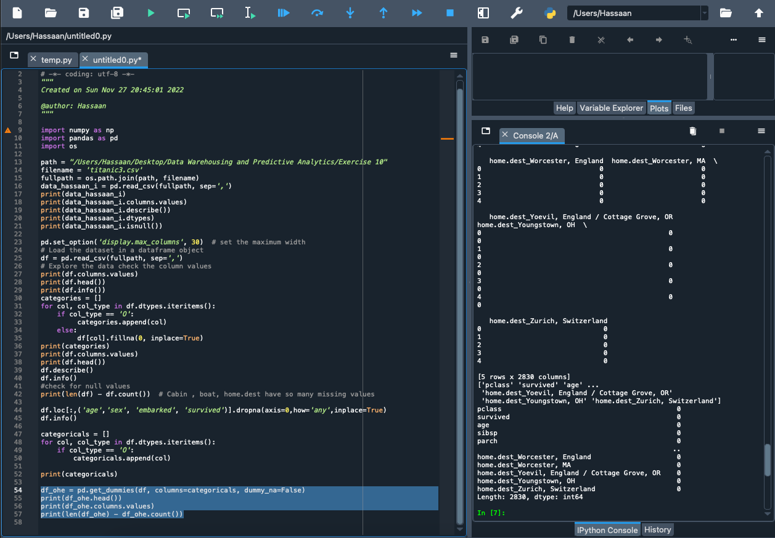

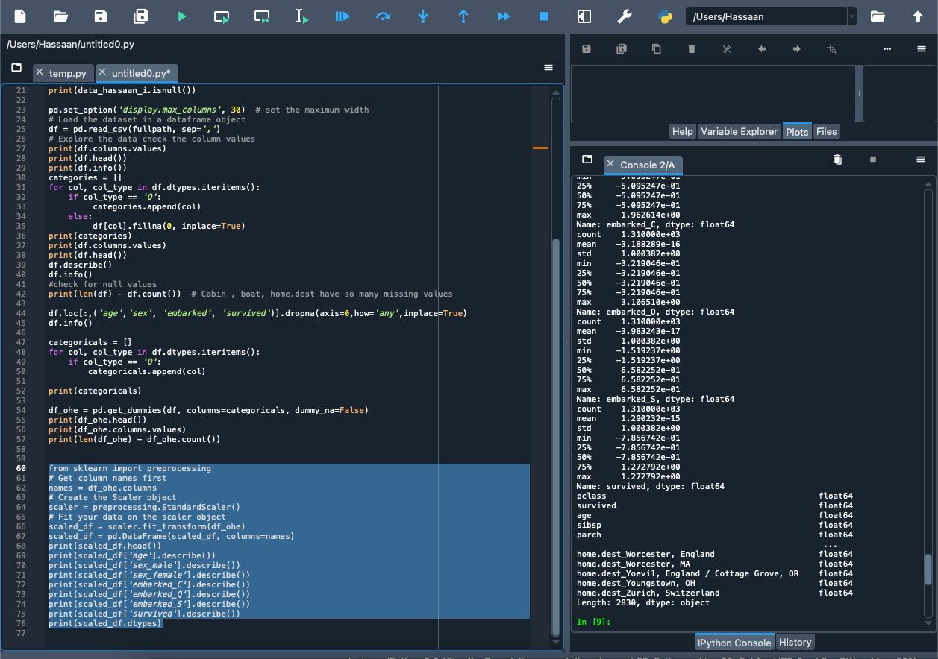

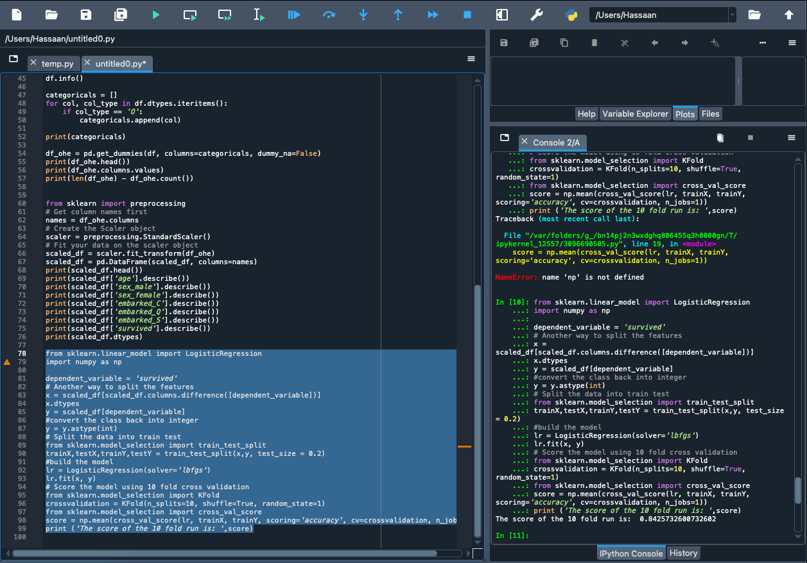

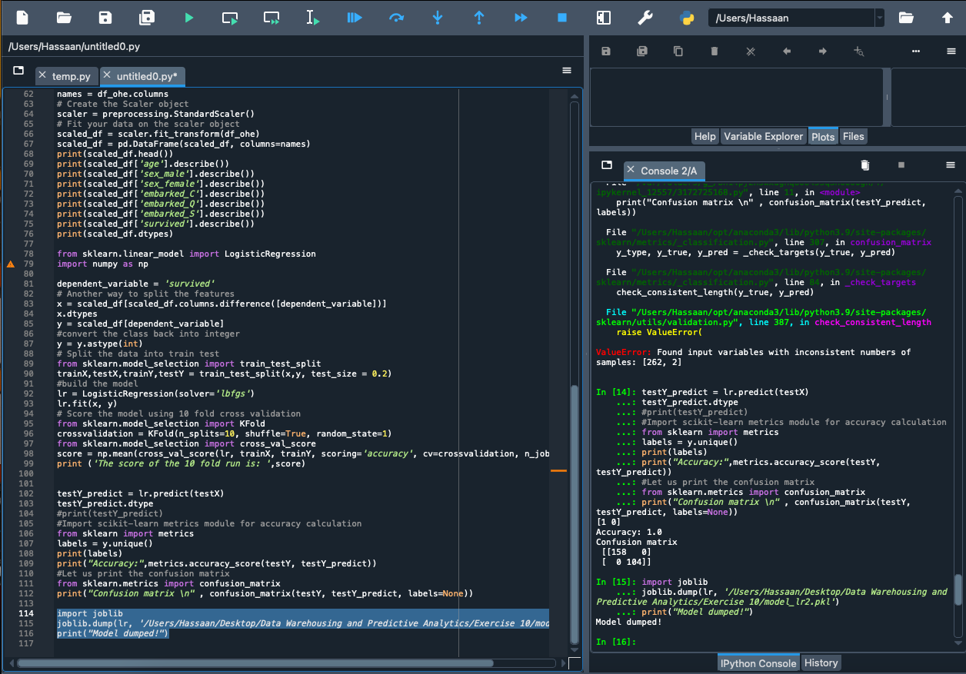

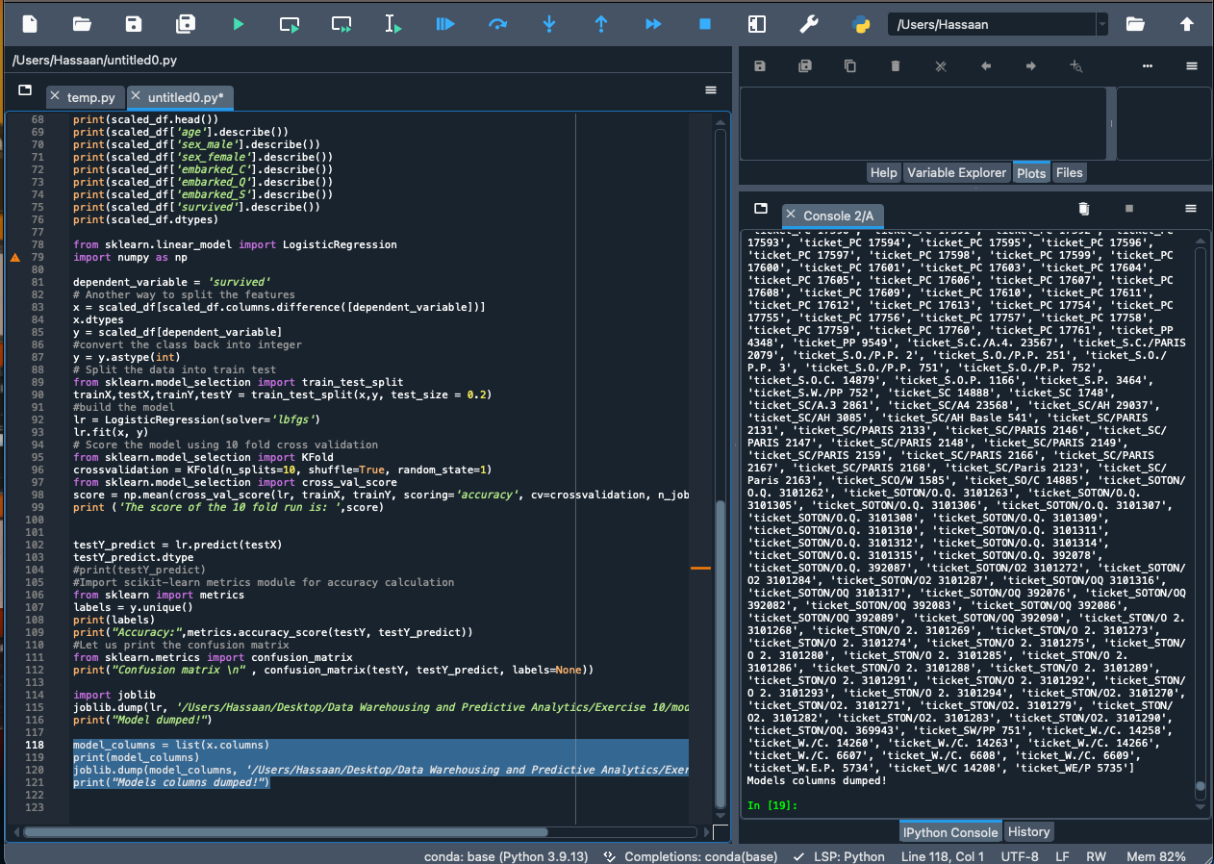

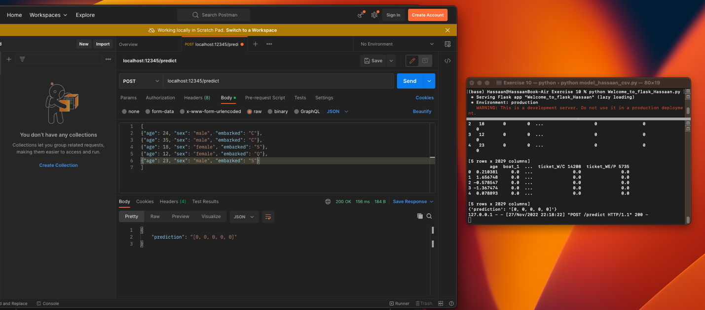

Explanation:

First we edit and run python commands in the terminal. In the next exercise we run a pre-existing python file through the terminal. Exercise#3 has a run a flask server on out local port and make it display a message for us.

Exercise#4 make a logistic regression model on the titanic data set. We parse the values delete the null values. Then we convert the categorical values to numerical values using get dummies but we name it OHE. We then use the preprocessing from sklearn library and call Standard Scaler to standardize the dataset. We then train it 80% of the data and train it 10 times and output the score. We use the remaining 20% to test the dataset and output a confusion matrix.

Then we pickle the model and the columns separately and save them.

Exercise5 has us again create a flask on a local port and import the pickled models and run the server. We use postman to feed it data and get the predictions which for my side are that no one survives